IEEE IAS 2020 ROBOTICS CONTEST PROJECT REPORT

|  |  |
| --- | --- |
| Team name: | VOICE CONTROLLED WHEEL |
| Date: | 15TH MARCH 2020 |
|  |  |
| Team members: | 1. SHARAN RATHNAKUMAR 2. ABIN THOMAS TOMY 3. ARCHANA MANOJ |

**VOICE CONTROLLED SMART WHEEL CHAIR  
VIMAL JYOTHI ENGINEERING COLLEGE**

## Synopsis

Our project “Smart Wheel chair” aims at helping physicaly disabled people to move.Every individual wish to move freely but for those who are unfortunately suffering from this issue our project will be the best solution.

Our project is not just a voice controlled wheel chair, but an integrated solution for many of common problems faced,which got as feedback from many physicaly disabled people.

## Challenge Statement

The main problem we got is that the patient have to depend on other person to take them to wheel chair,that is they feel like a burdern.Another issue is that the person cant rest in bed position when they go out thus our chair have a simple solution for the above mentioned two problems.

and another feature we added is voice control so that a person can direct his wheel chair to himselves and also to drive it.There is an obstacle detecting sytem thus will stop even when the patient cant see it.).

## Mechanical Analysis and Design

The main mechanical working involves the transition of the Wheel Chair from Chair position to Bed position.There is a motor fixed below the chasis which is attached to the bolt and nut arrangement, thus when the motor rotates the bolt rotates along thus the nut is moved along bolt , where a cable arrangement will pull the seat forward and leg rest down, hence chair position is formed and when the motor is rotated in reverse the arrangement changes to Bed position.

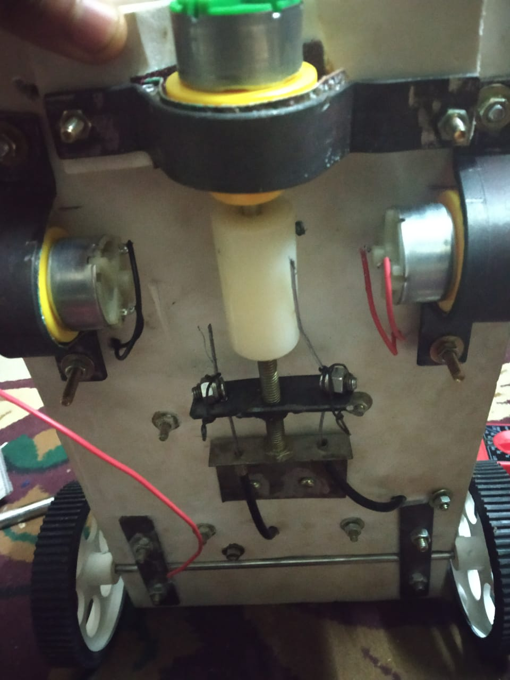

## Software Analysis and Design

***In this project we used Node Mcu (ESP8266)*** by with which we utillises the wifi connectivity where we connect our mobile so that we can use the voice recognition system to convert our words into text, now the word received by the board is processed and at the same time an ultrasonic sensor built on a servo motor will give the information whether any obstacle is present near by if no the board(ESP8266) will drive the motor with the help of a motor driver according to the given command.The next function is by the help of another motor we can shift the postion of chair , that is when the user says chair the motor shaft arrangement will rotate and shift into chair position if the user said bed the mechanism where motor spins so that the bed position is attained.

Components:

1.NODE MCU(ESP8266)

2.MOTOR DRIVER –L298N and L293D

3.MOTORS-4 GEARED MOTORS AND 1 SERVO MOTOR

4.ULTRA SONIC SENSOR

We made an android app using MIT APP INVENTOR , a voice recognition app, this app will recognize our voice and convert into command and sent it to NODE MCU as text (/command) , Thus based on the command the motor drive is operated.

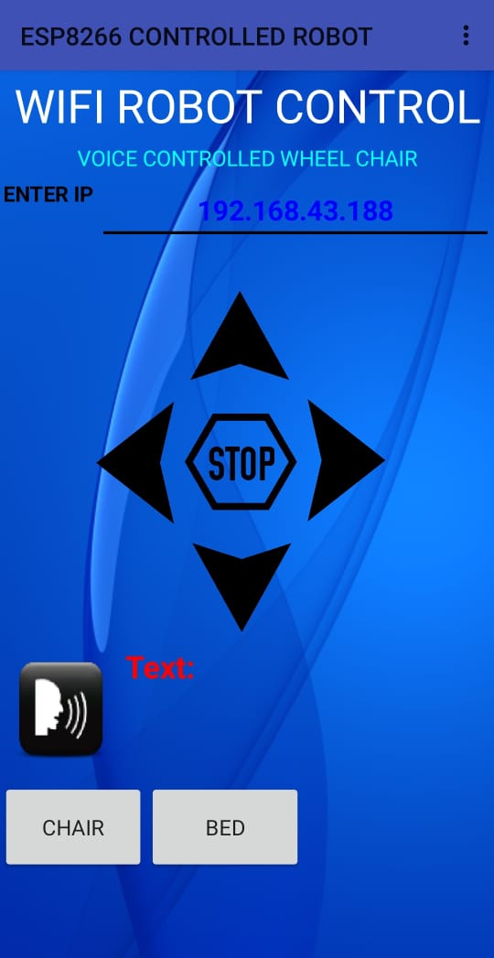

## Integration and testing

For the conventional wheel chair system one person is required to shift a person from bed to wheel chair and also to take wheel chair from where it is kept.

But our smart wheel chair can be oprated by voice command and also there is no necessity of another person to shift the patient to wheel chair, he himselves can do it thus making him independent and also free, because at any time he can call the chair towards him.

## WhatsApp Image 2020-03-16 at 1.13.26 AM (2).jpeg

## Conclusion

This project will help lot of people who are suffering with physical problems

and also will have a psychological impact , because all human beings have a mentality to be free and independent, but due to present circumstances they are not so.

We have learned a lot from this project and this project was very intereting one because we got to integrate a lot of things that we have learned as a part , like obstacle avoidance compined with voice recognition, for voice recognition system we learned to create an app using MIT app Inventor.